**Pelantikan Koordinator Program Studi Spesialis Orthopaedi dan Traumatologi**

**Fakultas Kedokteran Universitas Udayana 2022 - 2026**

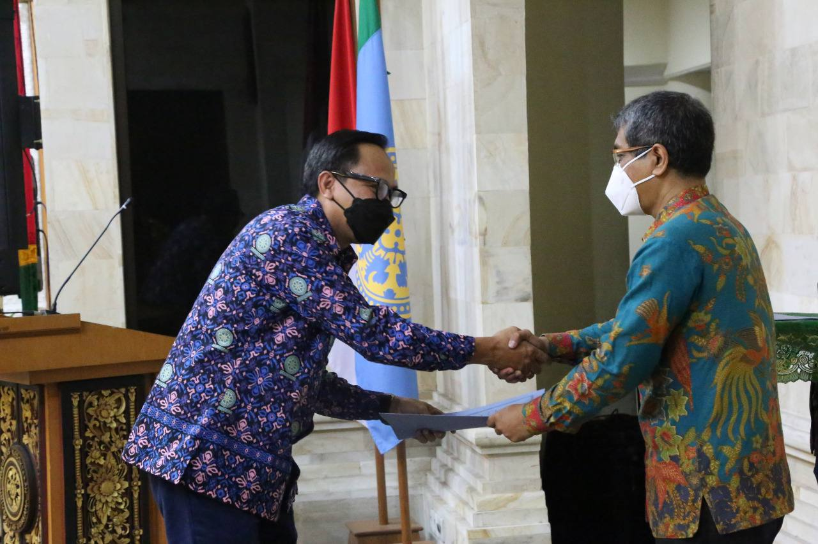

Denpasar, Fakultas Kedokteran Universitas Udayana melaksanakan pengambilan sumpah, pelantikan dan serah terima jabatan Koordinator Program Studi Pendidikan Dokter Spesialis – 1 periode 2022 – 2026. Pelaksanaan kegiatan yang dipimpin langsung oleh Dekan Fakultas Kedokteran Dr. dr. Komang Januartha Putra Pinatih, M.Kes yang berlangsung di ruang Pertemuan A.A Made Djelantik Fakultas Kedokteran universitas Udayana pada Hari Senin 10 Januari 2022.

Acara yang dihadiri oleh para Pimpinan akademisi di lingkungan Fakultas Kedokteran Universitas Udayana, para Koordinator Program Studi dan calon Koordinator Program Studi berlangsung dengan protokol Kesehatan Covid-19 dengan menggunakan masker serta *physical distancing* serta semua peserta telah menerima vaksin Covid-19. Acara pelantikan Koordinator Program Studi ini menerapkan protokol Kesehatan untuk menghindari penyebaran Covid-19. Dalam sambutannya Dekan Fakultas Kedokteran Universitas Udayana, menyampaikan rasa terima kasih kepada koordinator-koordinator program studi sebelumnya yang telah bekerja selama ini dengan baik. Harapan beliau dengan bergantinya koordinator-koordinator program studi spesialis ini semakin berkembang dan sesuai dengan Visi dan Misi fakultas kedokteran Universitas Udayana.

Dari Program Studi Orthopaedi dan Traumatologi, Dr. dr. IGN Wien Aryana, Sp.OT (K) telah dilantik dan menerima jabatan dari koordinator sebelumnya yaitu Dr. dr. I Gede Eka Wiratnaya, Sp.OT (K) sebagai Koordinator Program Studi yang baru dan siap melaksanakan serta melanjutkan tugas dalam masa periode jabatannya.

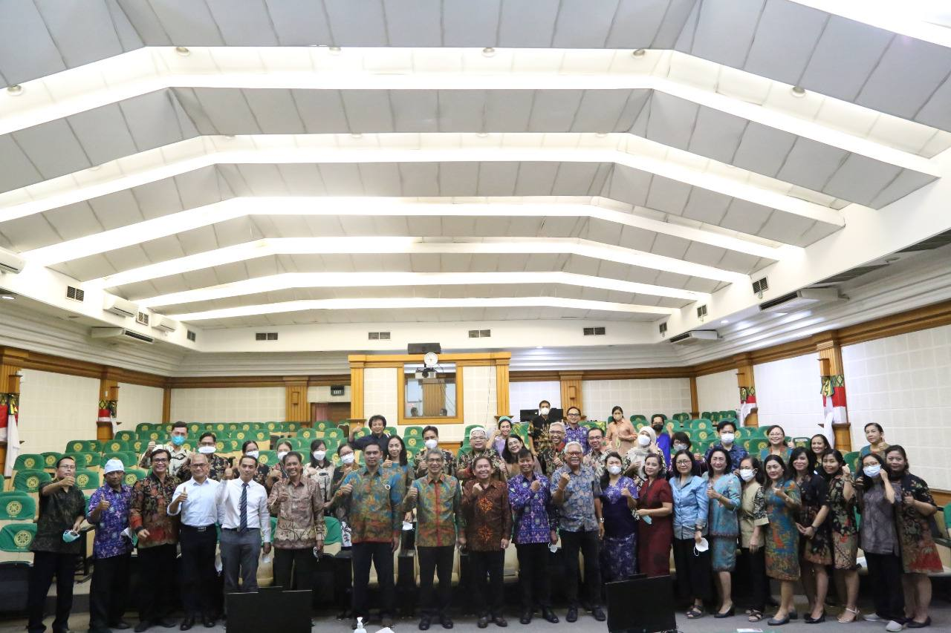

**Inauguration of the Orthopedic and Traumatology Specialist Study Program Coordinator periods 2022 – 2026 Faculty of Medicine, Udayana University**

Denpasar, Faculty of Medicine, Udayana University carried out the oath taking, inauguration and handover of the position of Coordinator of the Specialist Medical Education Study Program – 1 period 2022 – 2026. The activities were led directly by the Head of the Faculty of Medicine, Dr. dr. Komang Januartha Putra Pinatih, M.Kes which took place in the Meeting room of A.A Made Djelantik, Faculty of Medicine, Udayana University on Monday 10 January 2022.

The event which was attended by academic leaders in the Faculty of Medicine, Udayana University, Study Program Coordinators and prospective Study Program Coordinators took place with the Covid-19 Health protocol by using masks and physical distancing and all participants had received the Covid-19 vaccine. The inauguration ceremony of the Study Program Coordinator implemented the health protocol to avoid the spread of Covid-19. In his remarks, the Head of the Faculty of Medicine, Udayana University, expressed his gratitude to the coordinators of previous specialist study program coordinators who have worked well so far. He hopes that with the change of coordinators for this specialist study program, it will develop and be in accordance with the Vision and Mission of the medical faculty of Udayana University.

From the Orthopedic and Traumatology Study Program, Dr. dr. IGN Wien Aryana, Sp.OT (K) has been inaugurated and accepted the position of the previous coordinator, namely Dr. dr. I Gede Eka Wiratnaya, Sp.OT (K) as the new Study Program Coordinator and is ready to carry out and continue his duties during his term of office.